Help my teammates repair the rifle today, I find that they all use different brands and parameters of high torque NdFeB motors (Nd-Fe-B high strong magnet), I removed 4 motors and tested their efficiency.
Motor efficiency refers to the ratio of the output speed with load to the no-load speed, high-efficiency motors save power and generate less heat.
The four motors shown below:
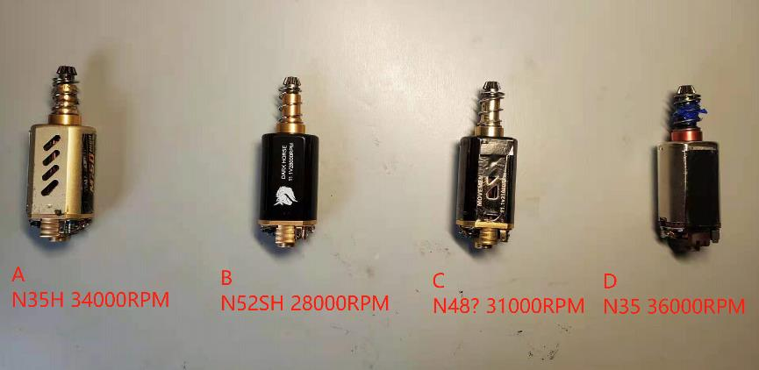
A:N35H 34000RPM
B:N52SH 28000RPM
C:N35 or N48 31000RPM (Unable to find the motor magnetic shoe level, by hand twist and torque comparison, guess it may be N35 or N48)
D:N35 36000RPM

The four motors are installed in the same rifle in the order of ABCD, use the same configuration of the gearbox grip, same battery, fully charge to 12.6V each time, conduct sonic test, get the RPS, then calculate the conversion efficiency of each motor.
The gears used are 12:1 weight reduction hollow steel cut gears, the spring is M85, and the initial speed is about 270FPS (limited by local regulations).
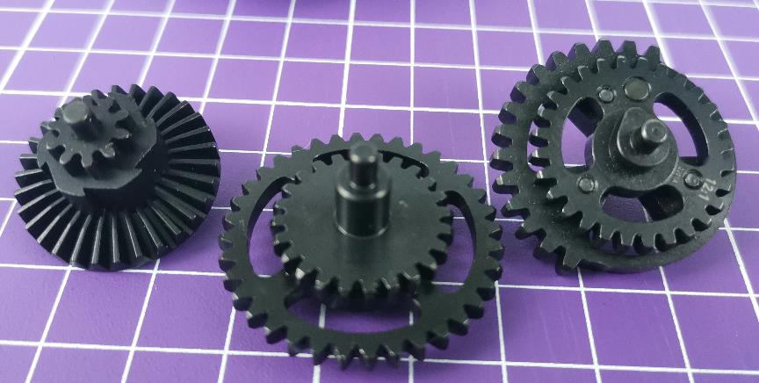
Get the track Waveform Diagram as below
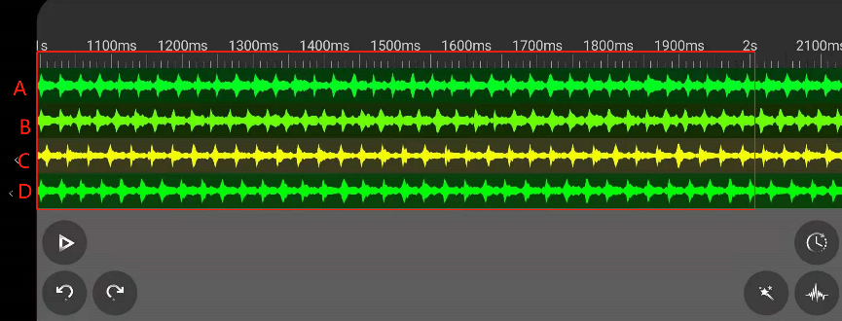
By calculating the peak value in one second, we get the RPS of each motor:
A:36
B:37
C:33
D:35
The formula for calculating efficiency is RPS*12*60/no-load speed, we get the following data
Group | Magnetic shoe model | 12.6V RPS | 11.1V no-load RPM | 12.6V loaded RPM(RPS*12*60) | Relative efficiency
A | N35H | 36 | 34000 | 25920 | 76.23%
B | N52SH | 37 | 28000 | 26640 | 95.14%
C | N35 orN48 | 33 | 31000 | 23760 | 76.64%
D | N35 | 35 | 36000 | 25200 | 70.00%
Please note:
1. The no-load speed marked by the manufacturer is measured at 11.1V, and the load voltage in this test is 12.6V, so the efficiency cannot represent an absolute value, and can only be used as a comparison reference for the efficiency performance of different types of motors
2. Efficiency is also directly related to the spring we use. If a high FPS spring is used, the efficiency may change. It is speculated that the more efficient motor should have a more obvious efficiency advantage under high load conditions (high FPS).
3. In addition to the magnetic shoe strength, the efficiency is also related to the coil
4. Because the motor is not brand new, the accuracy of the efficiency data may be affected by the high temperature demagnetization of individual motors.
5. From the test results, it can be seen that the B motor with the lowest no-load speed achieves the highest RPS in actual use due to its ultra-high efficiency, and at the same time, the heating energy consumption is lower. Although the no-load speed of the D model is high, due to low efficiency, the actual RPS is in a backward position, and it also brings more heat.
The above data are obtained from my non-professional tests and are only for players' reference.

